Basic Linux commands Assignments

Assignment 1:

When we connect to a non-existent user, it does not allow to login. As expected, it shows an error it didn’t work. Here is the screenshot for the incorrect user or username.

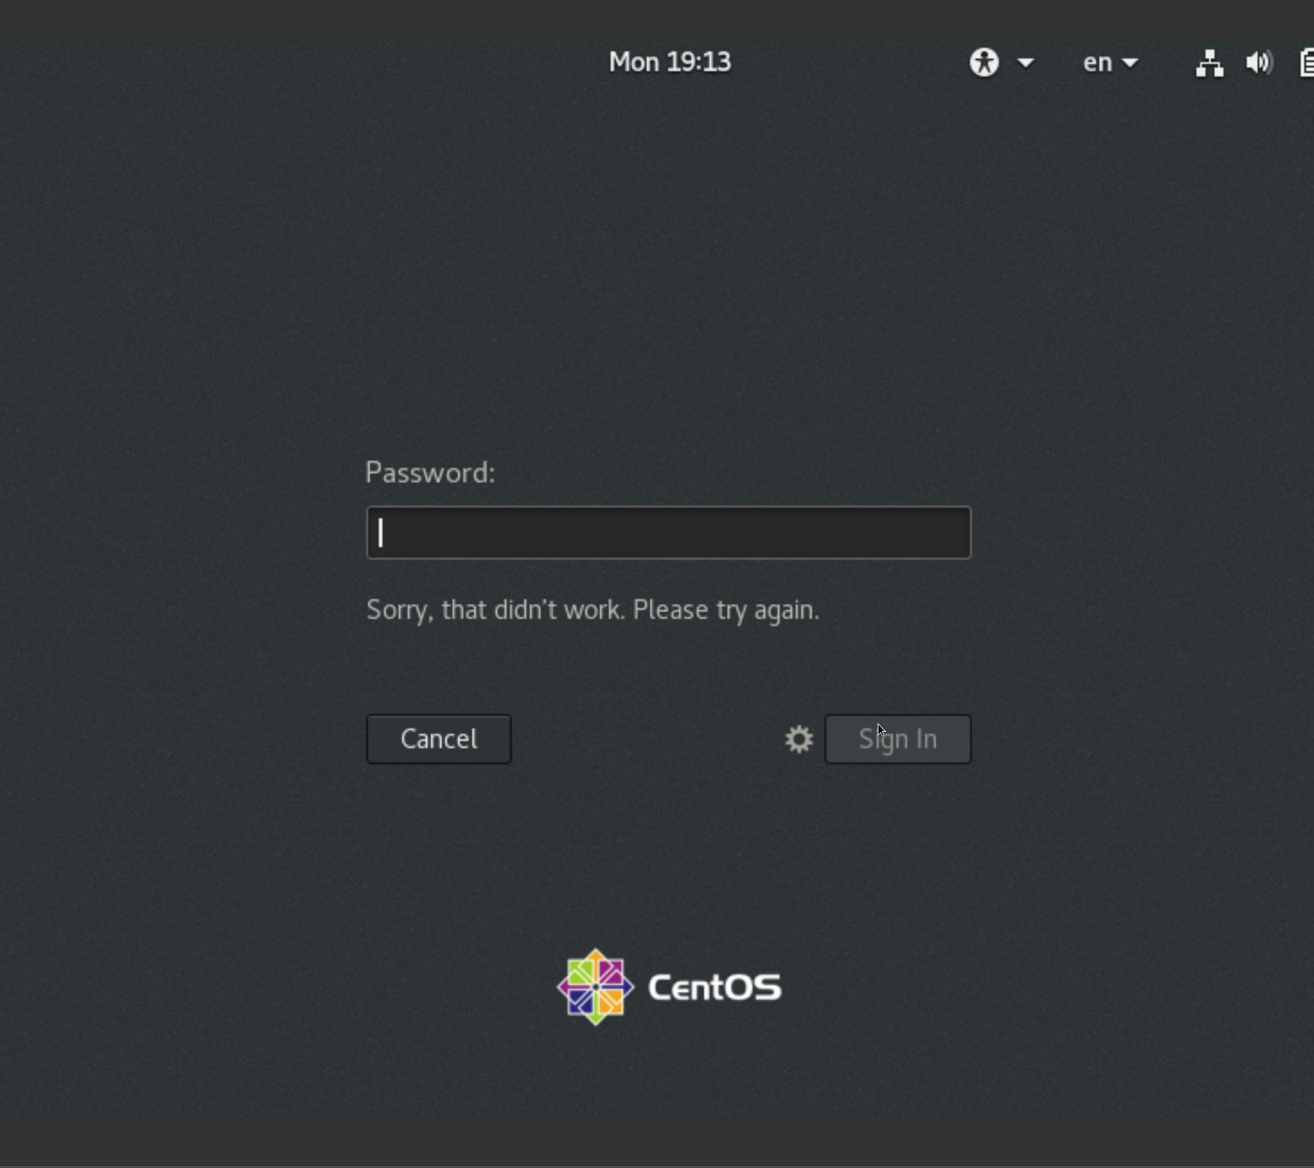

Assignment 2:

Password changing

1. Changed password for the current user to IneuR0n#42, it was successfully changed and have attached the screenshot for it.

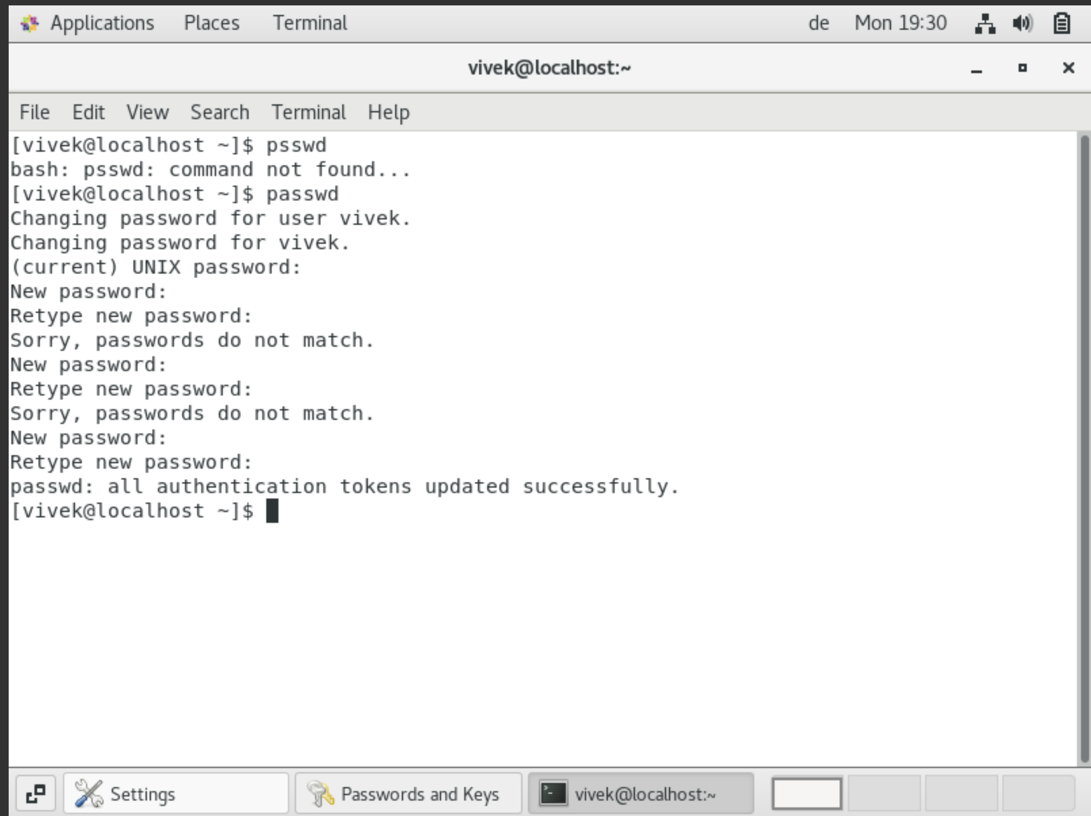

1. Tried changing the password from IneuR0#42 to abcd/1234, couldn’t change the password, “ the password is shorter than 8 characters”.

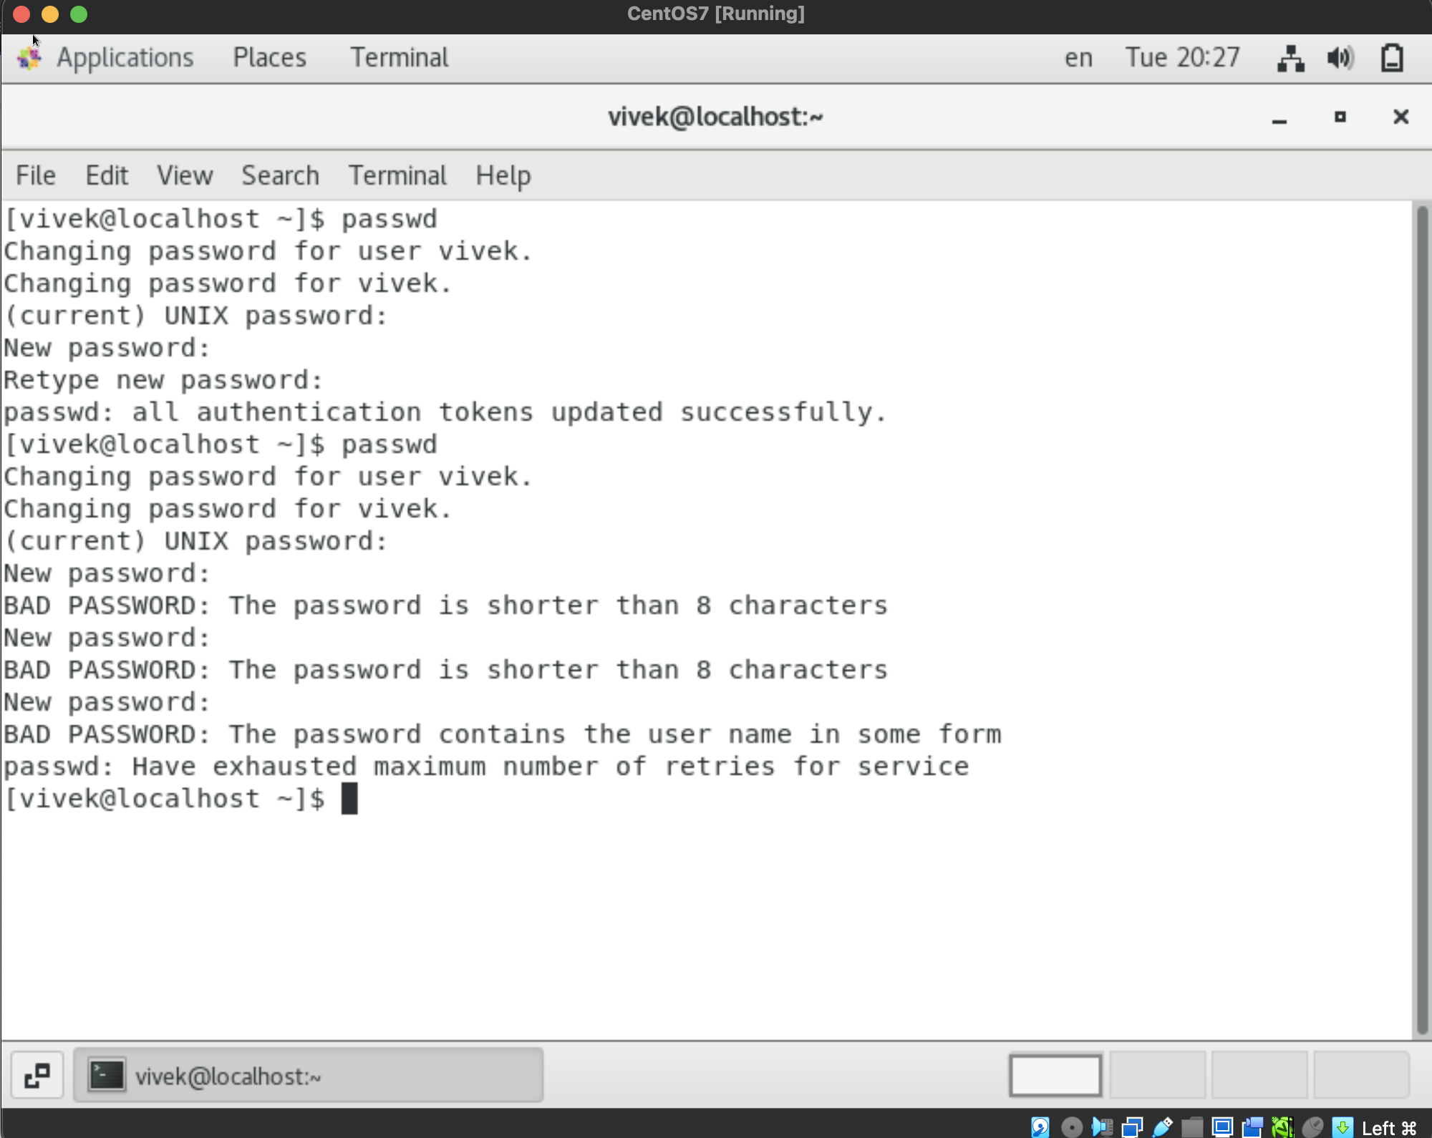

1. When I try to change the password with an empty character, “No password supplied” error appears.

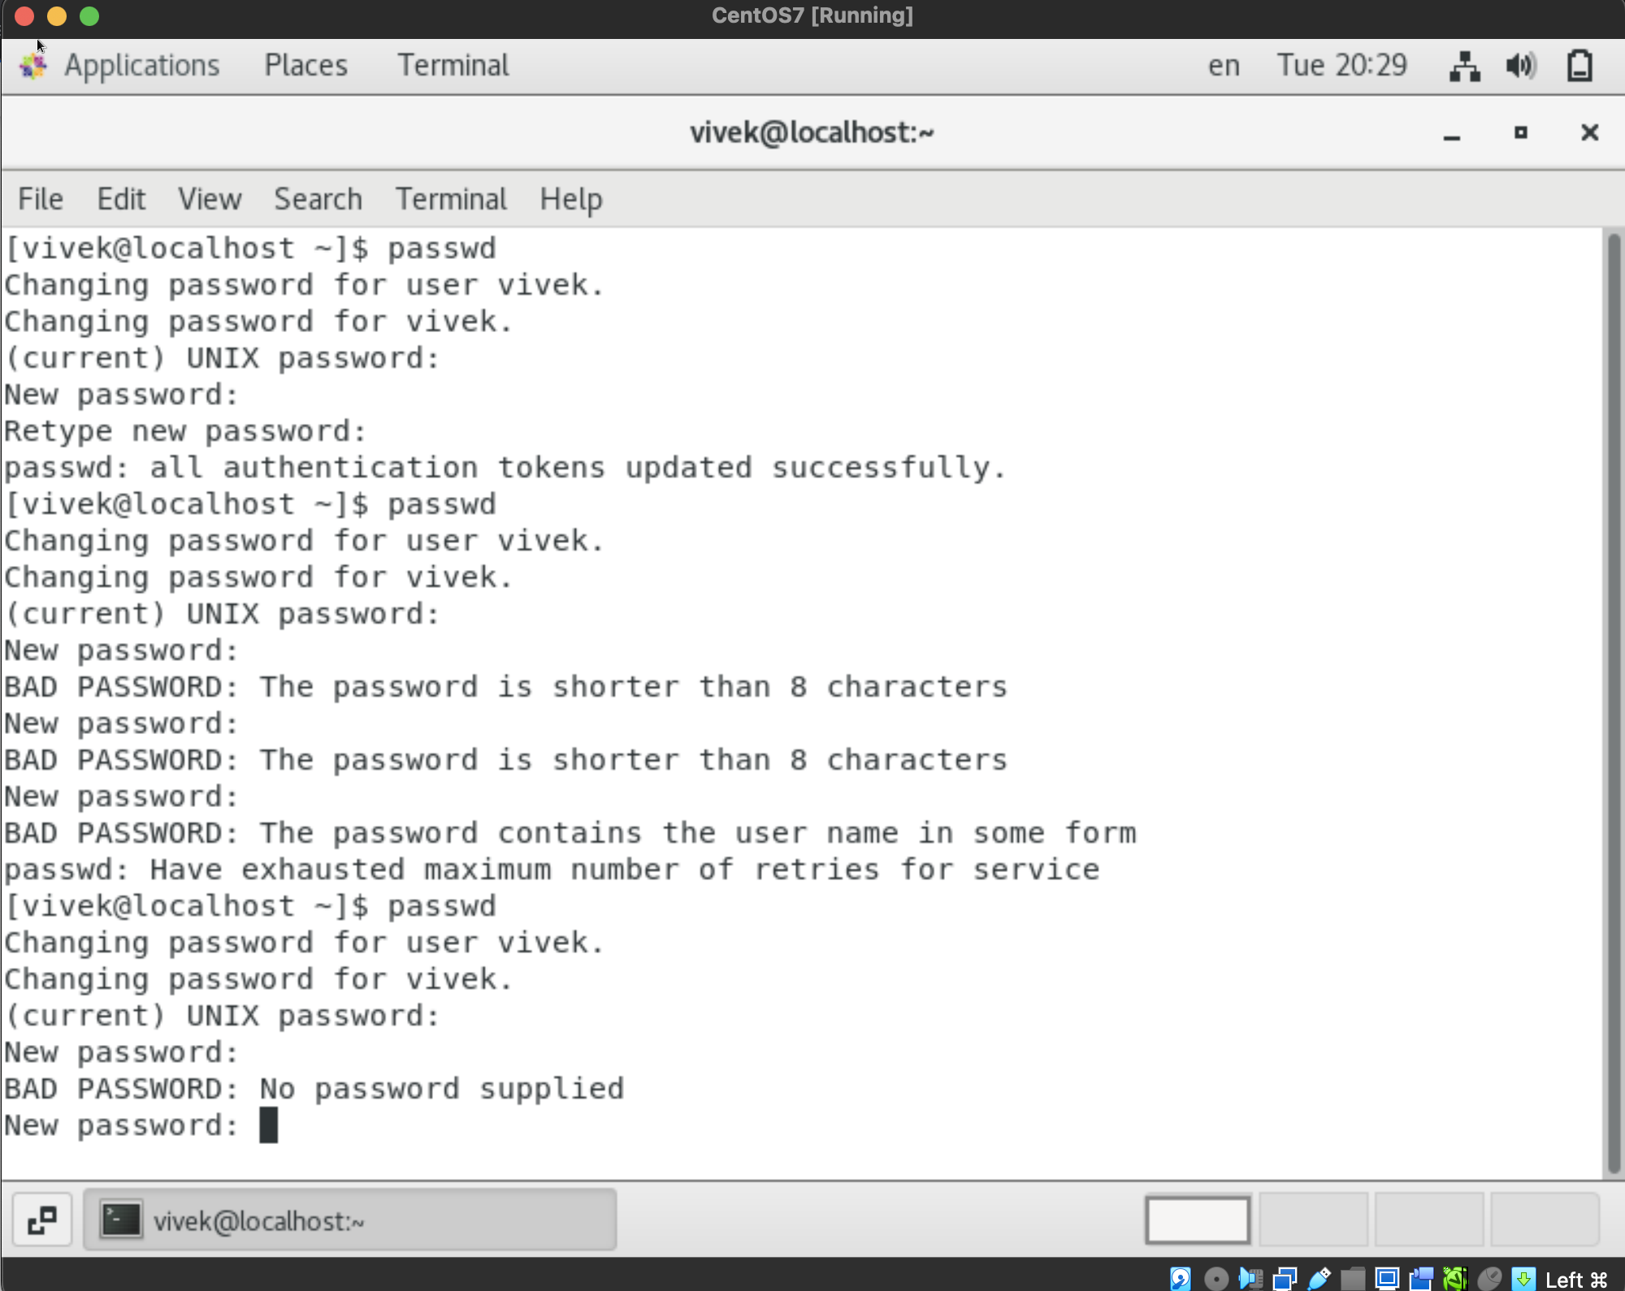

Assignment 3:

Working with directories:

1. When “cd /” and “ls”, command are entered, the cd / command goes to the root directory of the OS and when ls is entered, it shows all the base directories available in the machine.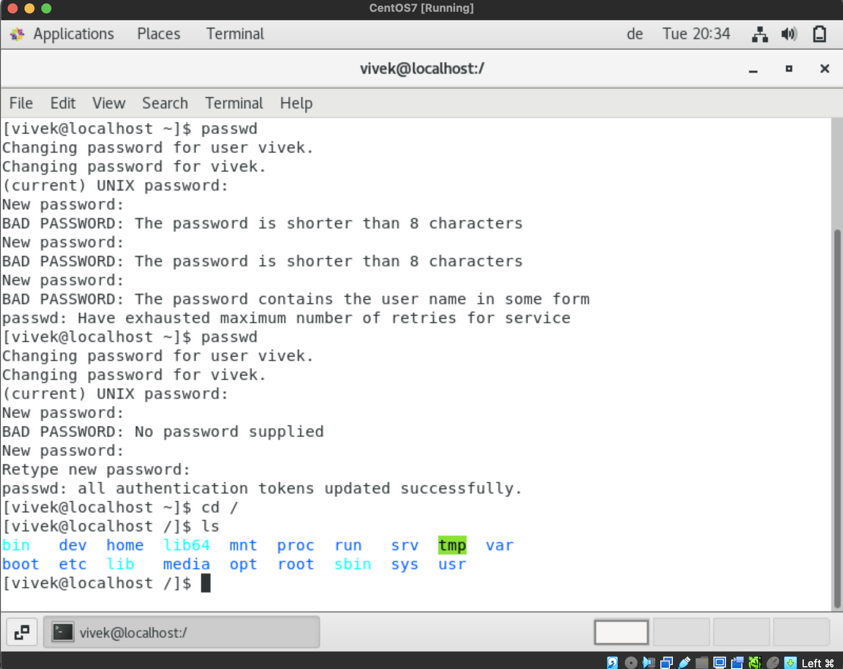
2. When cd /home is entered, the path goes for the home directory of the current user and when ls is entered it shows the current user’s directory.

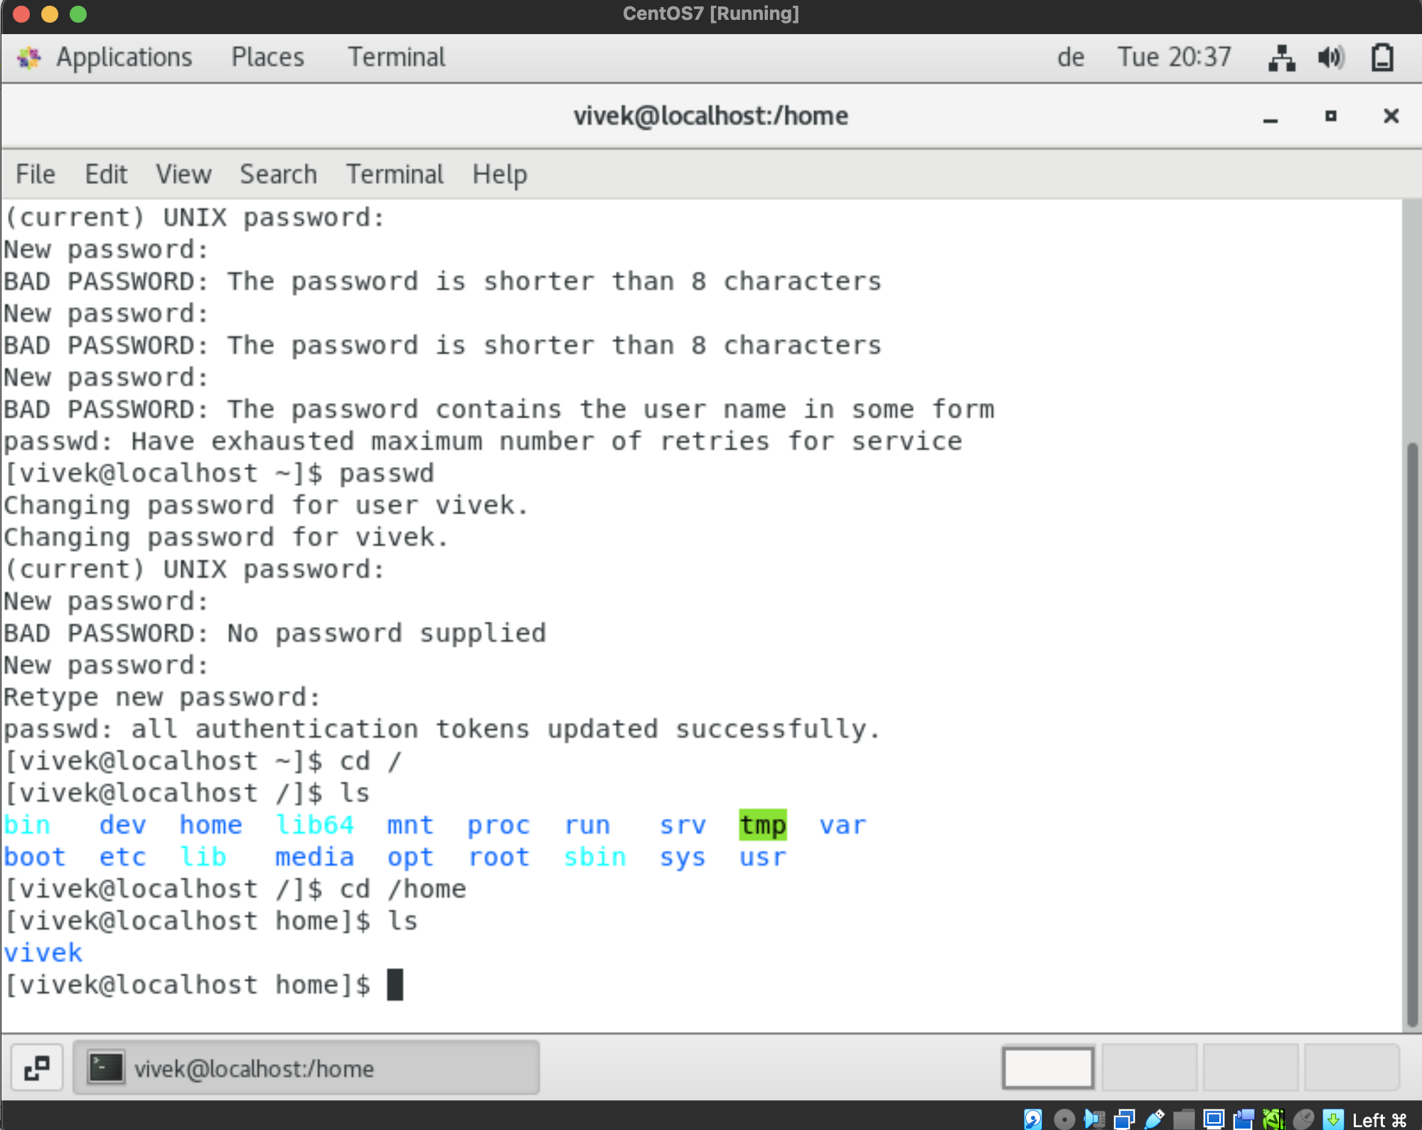

1. When cd .. is entered, from the home directory, it goes one step up of the dir tree and it goes to root directory.

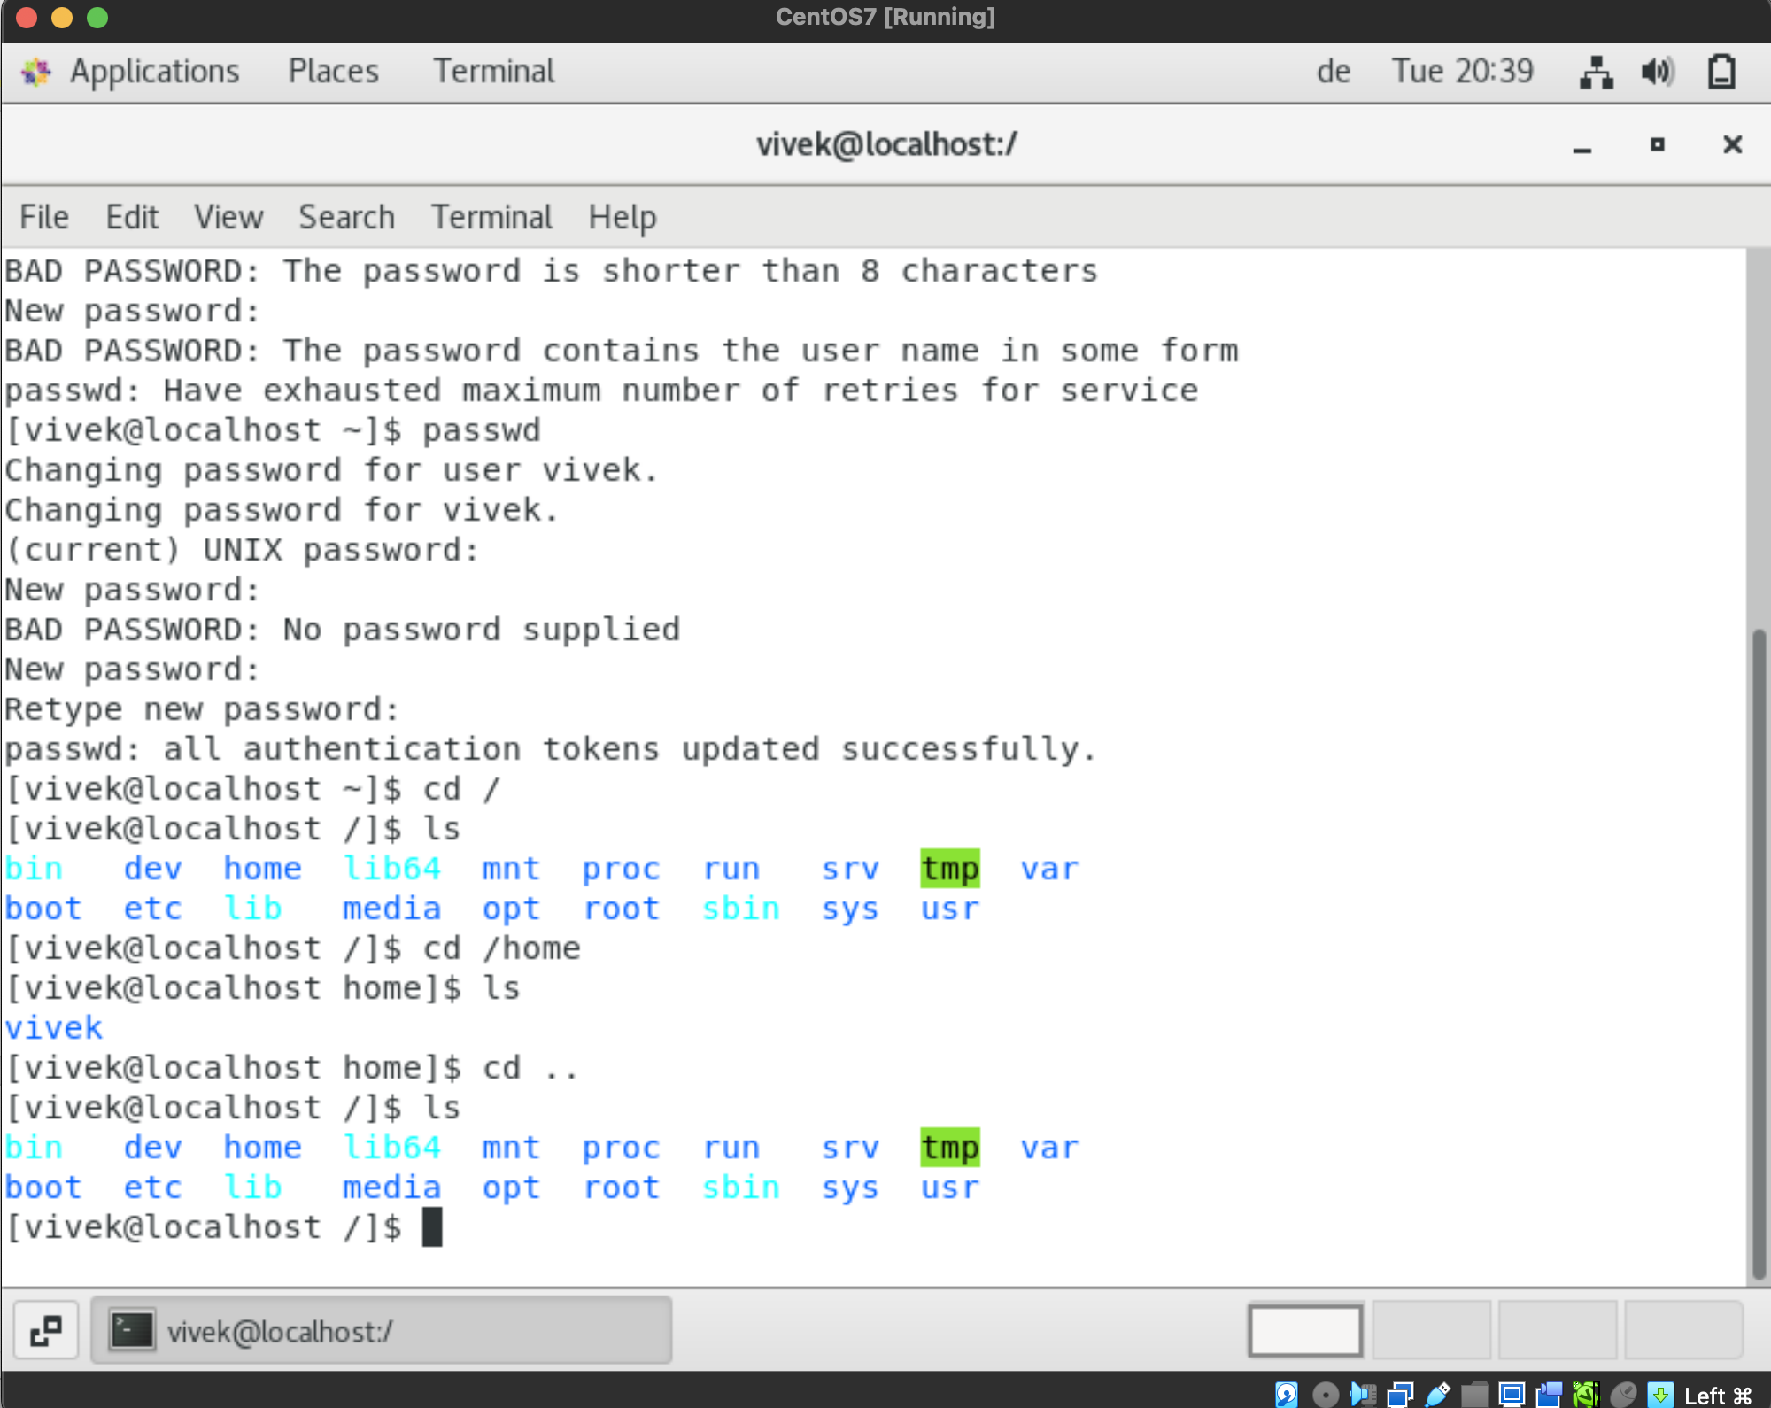

1. When entering “ cd /var/www/html”, it shows there are no file directory available and now if cd is entered, the pwd goes to current users working directory.

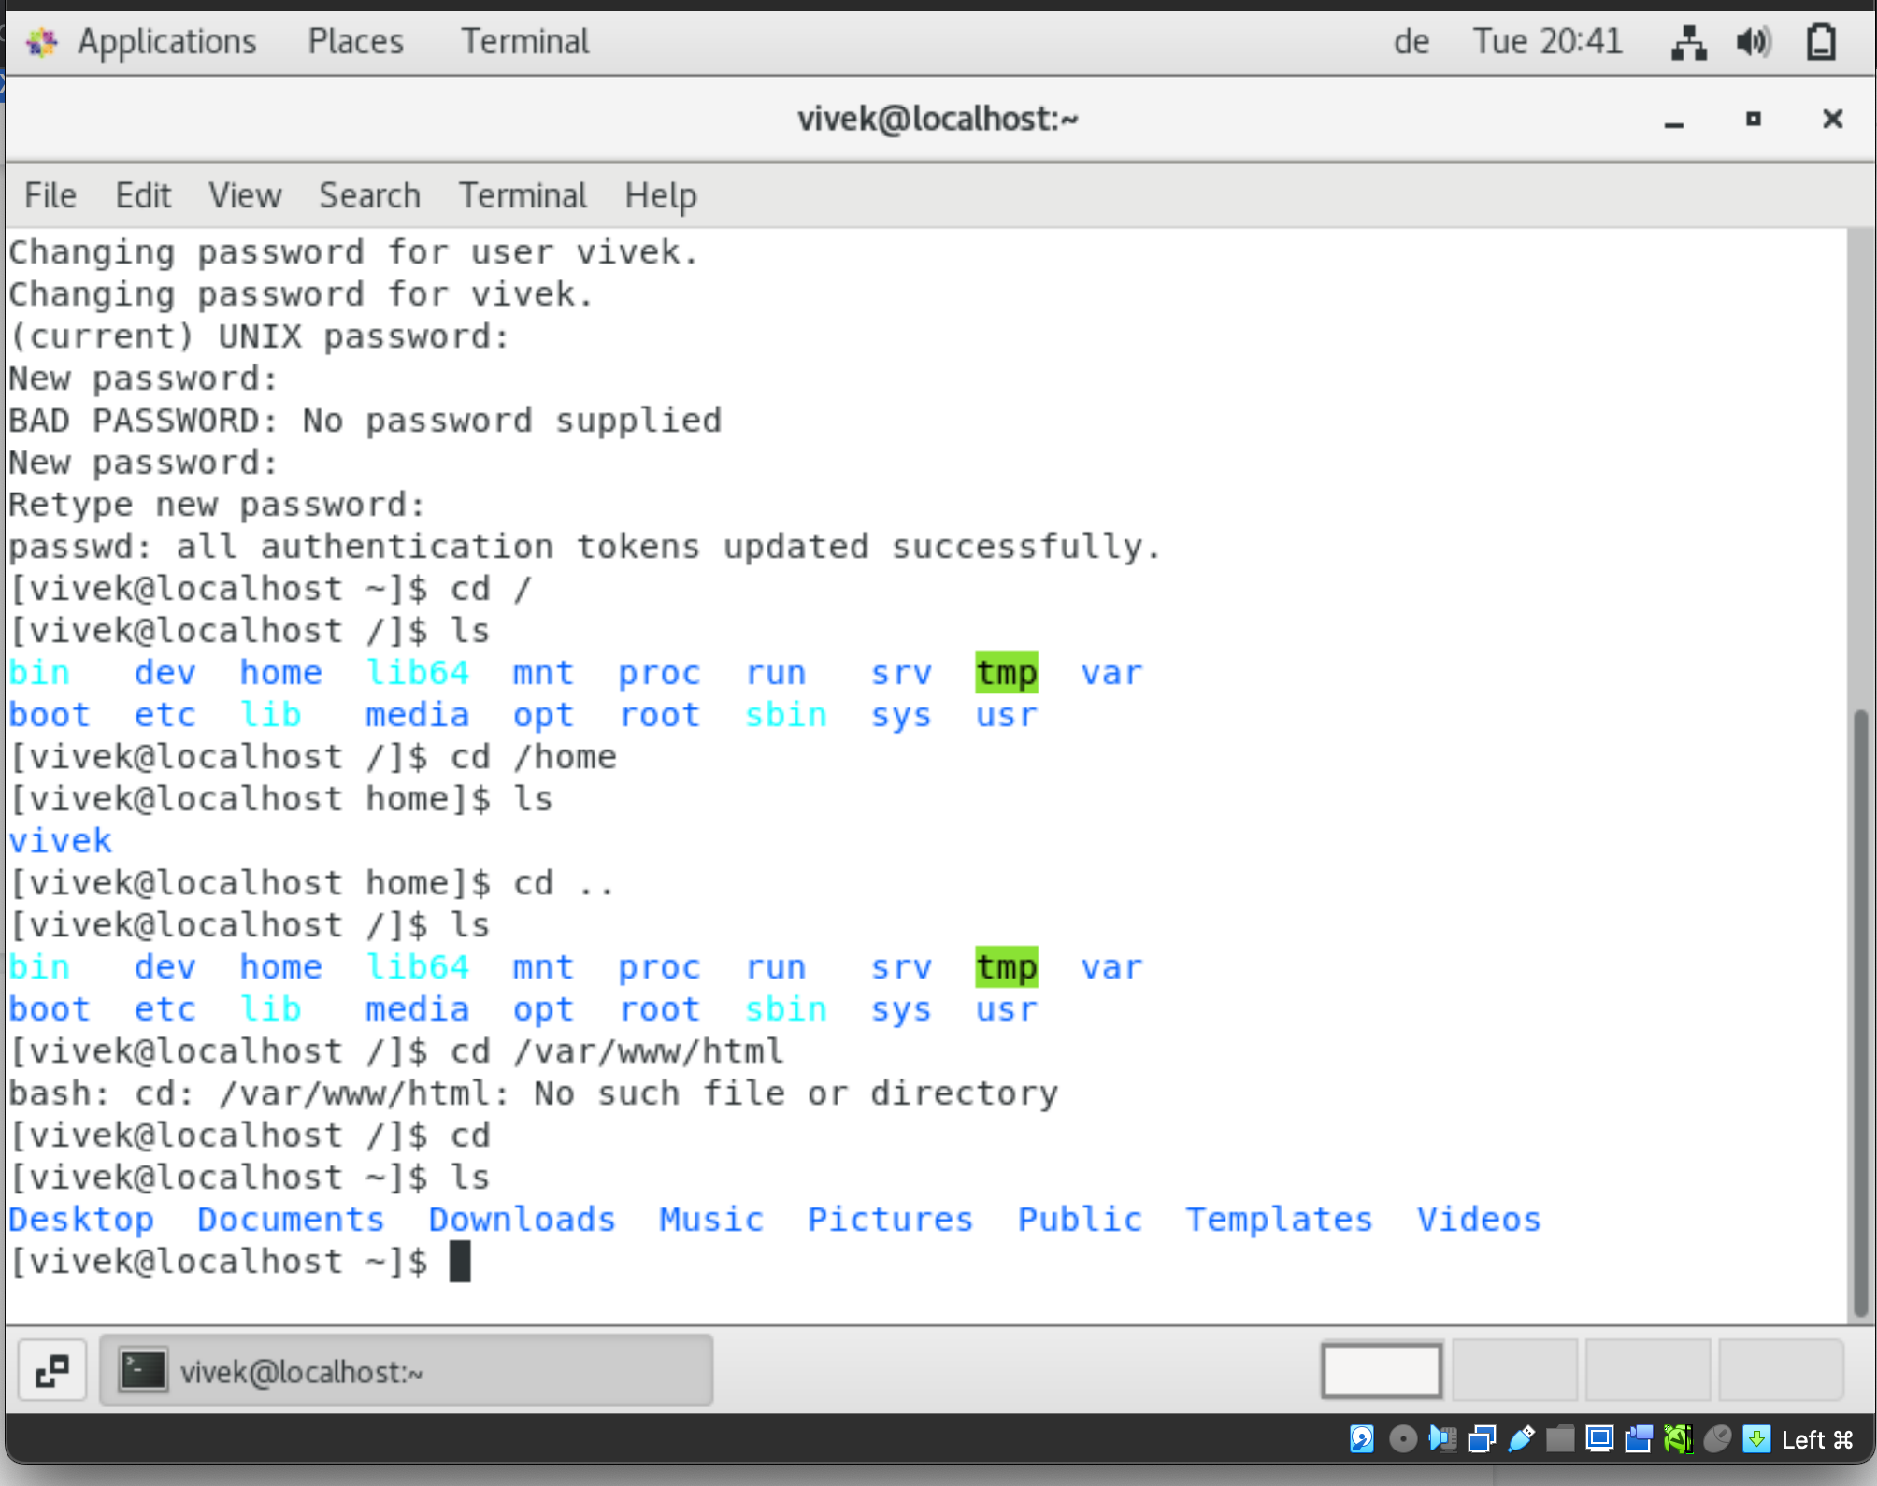

1. When we do “cd /root”, since the current user is not a root user, it has showed the permission error. When “ls” is entered, it shows the current users pwd dir.

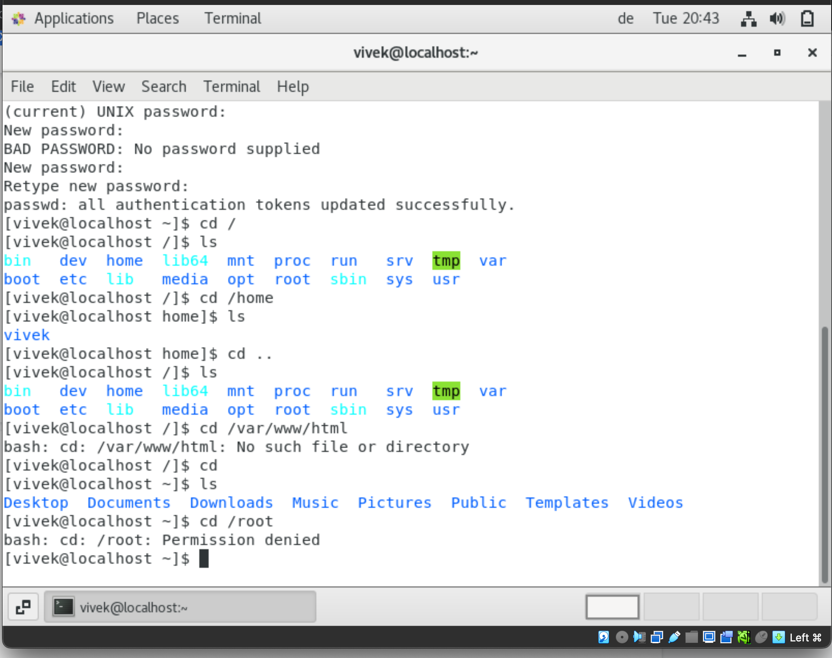

Assignment 4:

Working with file listing:

1. When “cd /etc” and entered “ls”, the etc folder contains a lot of files and folder that are mainly for “Networking configuration”. These files are mainly used by the centos for the networks. There files are not used by a common user.

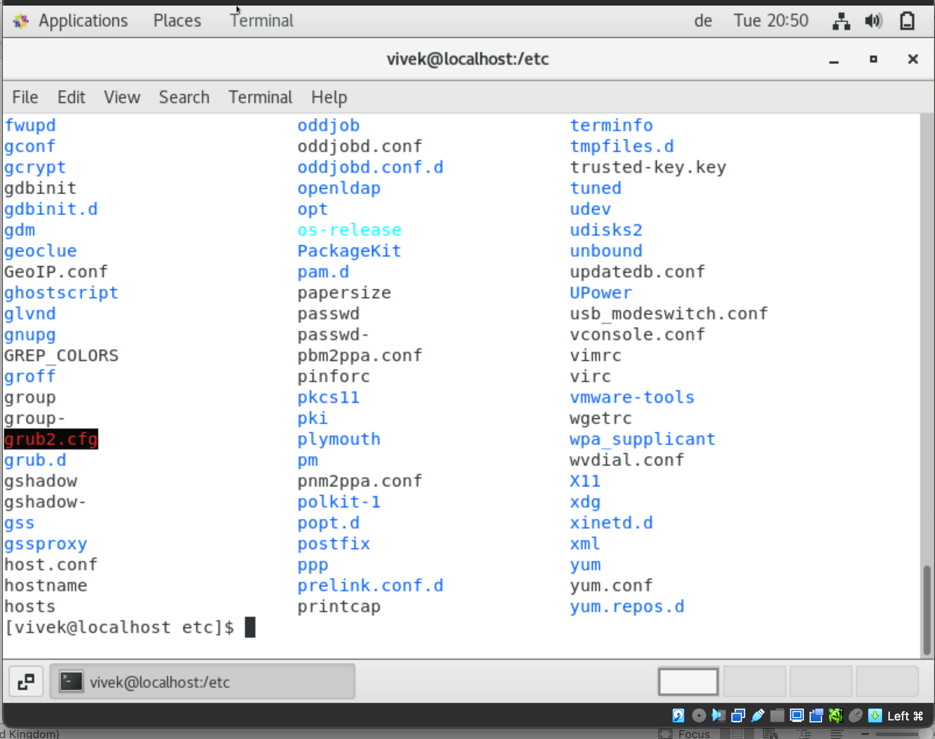

1. When “ls -all” in the etc folder is entered, it lists all the folders when was created and the permissions for each and every files and folders are shown.

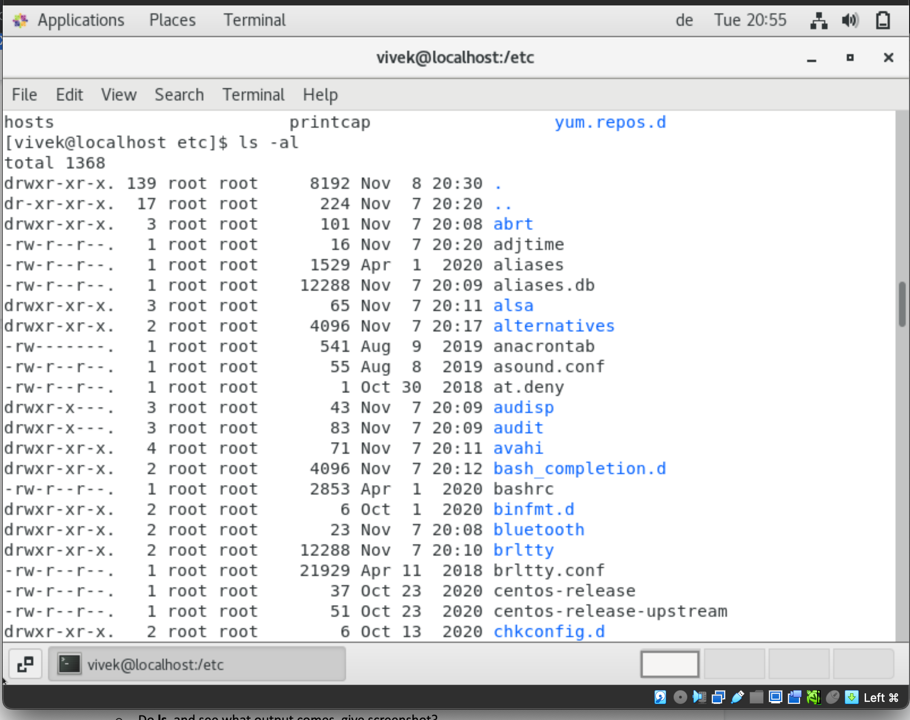

1. When “ls -i” is entered, it shows all the current directories files and folder with its index number for the reference.

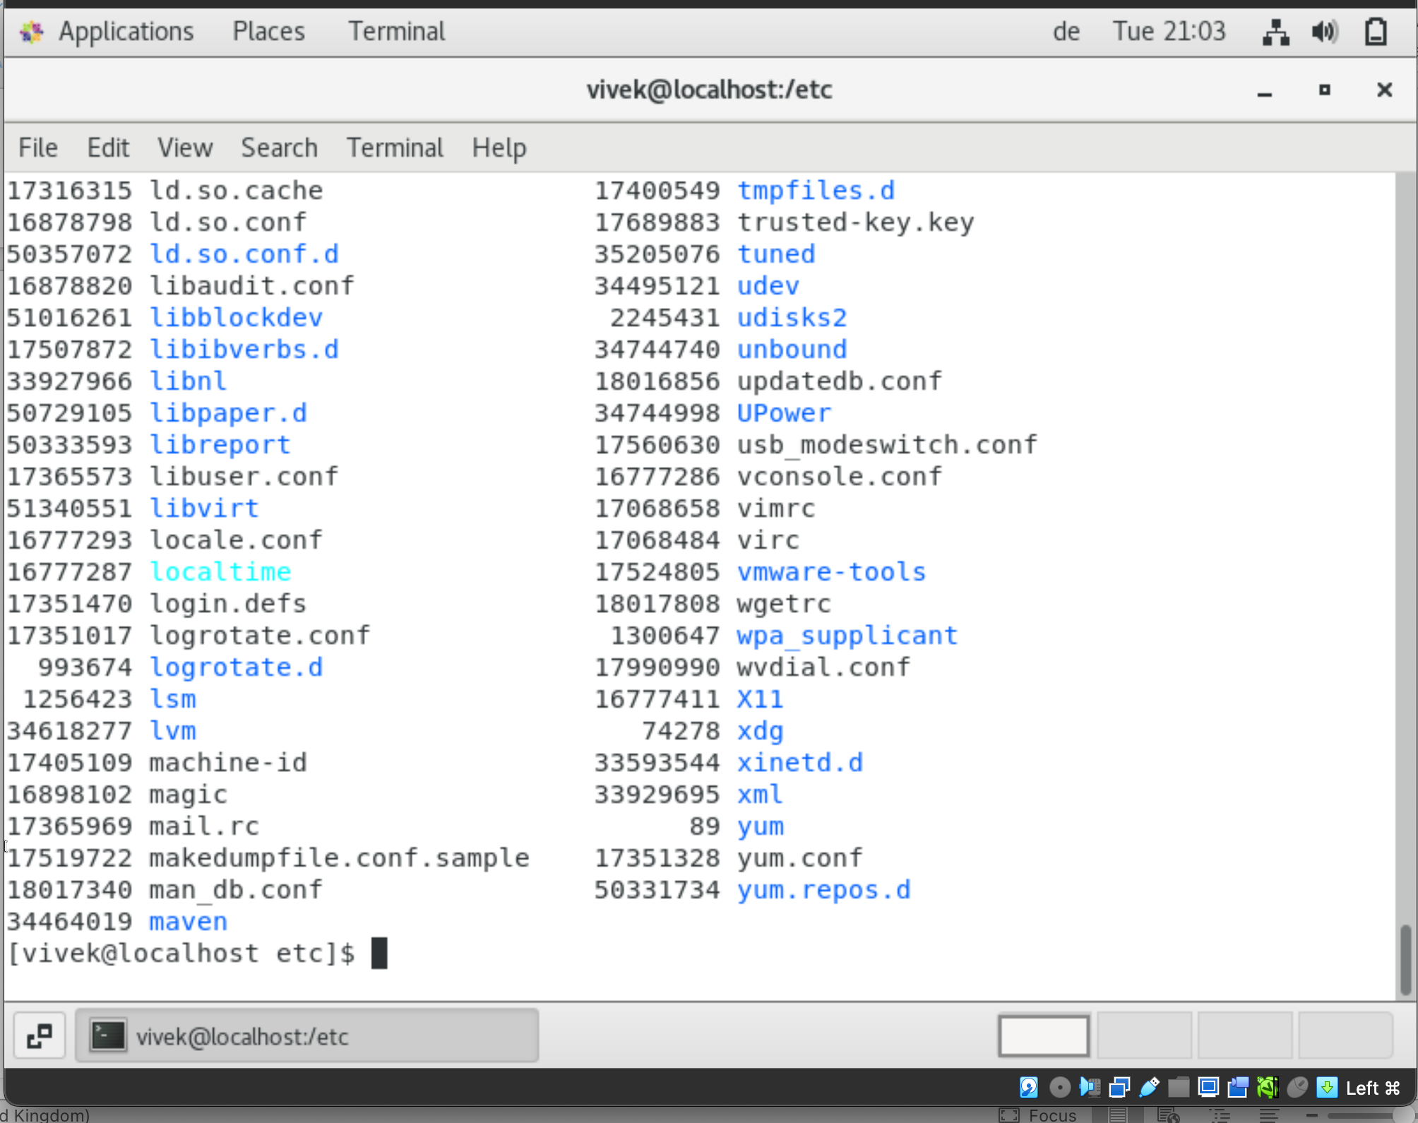

Assignment 5:

1. After restarting the machine, then entered “pwd”, it shows the current users working home/USER directory.

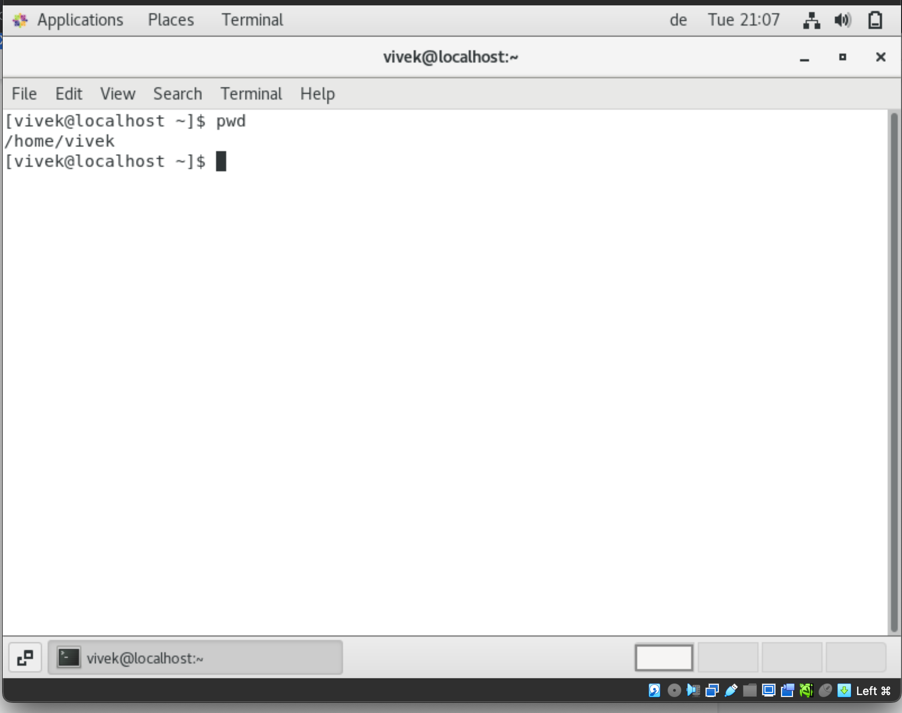

1. When “cd /var and ls” is entered, the list of files shows the variable or the temp files in the machine such as websites, temp files and others.

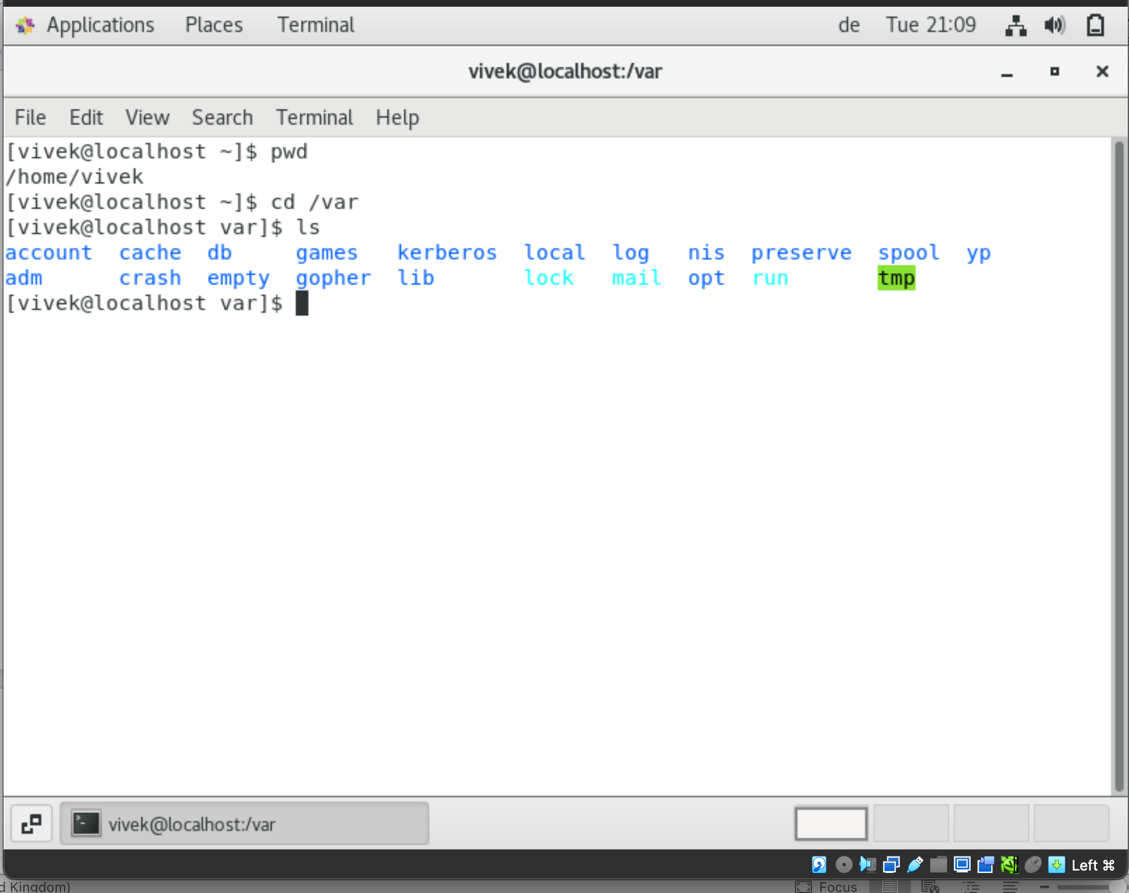

Additional assignments:

Making the centOS, full screen. Additional dependencies are installed and VirtualBox Addition software are installed and executed.

